Starting a backend project
Step 1
Create a new folder somewhere. Ideally have “backend” in the name so it’s easy to know which is which. Example “someapp_backend”.

Step 2
Open the folder in visual studio code

Step 3
Make sure you have the terminal open. If not, at the top you have the button for terminal -> New Terminal

Step 4
In the project folder, create a file called main.py
And then paste in the initial code we need for creating a fastapi app

main.py
from fastapi import FastAPI

app = FastAPI()

@app.get("/")
def read_root():
return {"Hello": "World"}

Step 5
In the terminal, run the command
Py -m venv venv
This will create a virtual environment folder called venv, this is where any python libraries / dependencies for the project will get installed

Then activate the virtual environment through the command:
On Windows | On Linux
venv/scripts/activate | source venv/bin/activate
There should now be text (venv) in the terminal to signify its active.

Step 6
To install fastapi, in the terminal run the command:
Pip install fastapi[all] pymongo pydantic
This will install everything fastapi requires to function, it will also include what we need for mongoDB (database)

Step 7
Now to run the project using a command:
Uvicorn main:app –reload –port 8001
It’s 2 dashes, no space - -. Gdocs make it look like 1 dash
It will look like this
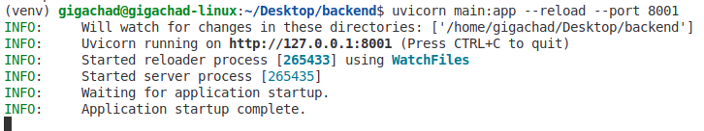
Explanation: –reload will restart the server on every change to your code so you can test it without having to restart manually every time. Port 8001 is needed because the default one (8000) is used by the college for something else. You likely dont need that part at your own pc at home.

Step 8
Open the app. Go to http://127.0.0.1:8001 or ctrl + left click on the address in the terminal to open the page. It will look like this:
Then add /docs to the path ( http://127.0.0.1:8001/docs ). It will look like this
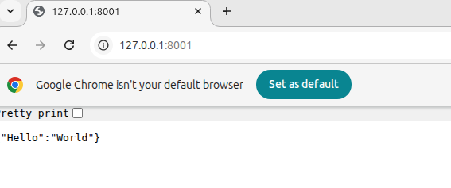

Step 9 (Optional, only if using Github)
In the project folder, add a “.gitignore” file to prevent the venv folder from being uploaded to github (it will break things)
It will look like this
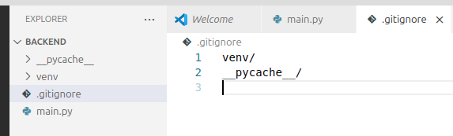

Step 10 ( requirements.txt)
Run
Pip freeze > requirements.txt
To save a list of dependencies into a requirements.txt file

Part 2 - CORS polic
We need to add a CORS policy in order to be able to call our backend server from our frontend app

Import cors, then after you defined the app variable, add the middleware

main.py
…other imports
from fastapi.middleware.cors import CORSMiddleware

app = FastAPI() # you already have this

app.add_middleware(
CORSMiddleware,
allow_origins=["http://localhost:3000"],
allow_methods=["*"],
allow_headers=["*"],
)

Note: If you host your frontend online, the localhost route would need to be replaced with the domain name your website is on

Part 3 - Project organisation
In your project folder, your structure should look like this:
- Project name
  - main.py //This is where our app starts
  - Routes //this folder is where we will organise our endpoint routes
    - Auth_routes.py //example of where everything related to authentication could go
  - Models //this folder is for files that define our data structure
    - Auth_models.py //example where to define how user data and data from login/register form could look like.

Example of structure:
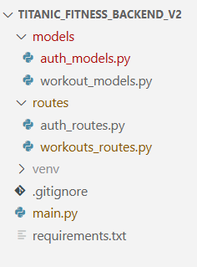

Step 1 - Model file example
Every model file will need to import BaseModel from pydantic

models/auth_models.py
from pydantic import BaseModel

class RegisterForm(BaseModel):
email: str
password: str
username: str

class LoginForm(BaseModel):
email: str
password: str

This is pretty self explanatory, var name on left, var type on right

Step 2 - Route file example

routes/auth_routes.py
from fastapi import APIRouter, HTTPException
from models.auth_models import LoginForm, RegisterForm

auth_router = APIRouter()

@auth_router.post("/register")
def register(register_data: RegisterForm):
new_user = register_data.model_dump()
return new_user

@auth_router.post("/login")
def login(login_data: LoginForm):
email = login_data.email
return {“temp”: “temp”}

Step 3 - Adding route to the app
We now need to make sure our app can see the routes in the file

main.py
…other imports
from routes.auth_routes import auth_router

app.include_router(
auth_router,
prefix="/auth", # prefix will be part of each route in that file
tags=["Auth"], # tags will appear in the /docs page
)

